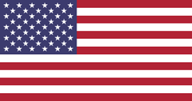
SCC: the Unites States of America

Part 1: The USA during slavery

Task 1 – Orientating
- What do you already know about slavery? Write it down.

Task 2 – Reading
Slavery in the US
People owning other people is called slavery. Enslaved people have to work for the owners, doing whatever the owners ask them to do. In the past, many societies had slavery. Now almost all societies consider slavery to be wrong. They consider personal freedom to be a basic human right.
Different societies had different rules for slavery. In some places enslaved people had to be freed after six years. In the United States, however, enslaved people usually stayed enslaved forever. They could not own any property. Their marriages were not legal, and their families could be broken up at any time. Enslaved people didn’t get paid, had no choice of jobs, and were not allowed to quit.
In North America the first enslaved people from Africa arrived in the English colony of Virginia in 1619. (America used to be a British colony.) Every state allowed slavery, but the large farms that used the most Africans were in the South. At first tobacco was the most important crop. Then in 1793 Eli Whitney invented a machine called the cotton gin (or cotton engine). His invention made cotton easier to process. This led to a huge demand for enslaved Africans to work on large cotton farms called plantations.
Some enslaved Africans worked in cities in people’s homes or as tradespeople, such as bakers or blacksmiths. Most, however, lived on plantations. They were divided into those who worked in the house and those who worked out in the fields. The house servants took care of the house and the family. They cleaned, cooked, did laundry, and sewed for the family and for the other enslaved people. Those who worked in the fields planted and harvested crops, built and repaired structures, and managed livestock (animals).
For enslaved Africans on plantations the work was always very hard. They were punished with beatings or other forms of torture for many different reasons. They did not have enough to eat, decent places to live, or good clothes to wear. They were not allowed to learn to read or write. They could also be sold at any time and separated from their family. Some tried to rebel against their owners, but they would be punished or killed for doing so. Black people were not even seen as human, but more like animals. A very disgusting thing.
During the 1700s some people in Great Britain came to think that slavery was wrong. They began the abolitionist movement, this movement wanted to end slavery.
During the civil war (burgeroorlog) between North and South USA, President Abraham Lincoln created the Emancipation Proclamation. This document said that all enslaved people in the Southern states were free as of January 1, 1863. However, the Southern states did not actually free the enslaved people. Freedom did not happen until northern troops captured every southern state during the war. The last state to be captured was Texas. When that happened, the last enslaved people were freed. Today the date of that event is celebrated as Juneteenth. At the end of the war the Thirteenth Amendment (anti-slavernij wet) to the Constitution (grondwet) finally put an official end to slavery throughout the United States.
- Waar of niet waar?
- Vroeger hadden alle maatschappijen dezelfde regels voor slavernij.
- Katoen was het eerste product waarvoor tot slaaf gemaakte mensen gebruikt werden in Amerika.
- Alle tot slaaf gemaakte mensen deden hetzelfde werk, namelijk werken op een plantage.
- Tot slaaf gemaakte mensen moesten vaak martelingen en mishandelingen doorstaan.
- De zuidelijke staten gaven de tot slaaf gemaakte mensen netjes hun vrijheid op 1 januari, 1863.
- Open vragen. Antwoord in volledige zinnen!
- Wat veranderde nadat Eli Whitney de ‘cotton gin (engine)’ had uitgevonden?
- Noem drie verschillende taken die tot slaaf gemaakte mensen konden hebben.
- Noem twee redenen waarom het leven als slaaf erg zwaar en onmenselijk was.
- Leg uit wat er nu gevierd wordt tijdens ‘Juneteenth’.

Task 3 – Reading
A road to freedom
Harriet Tubman was a very famous person during that time. She escaped from slavery in the southern United States. She then bravely helped lead many other enslaved people to freedom.
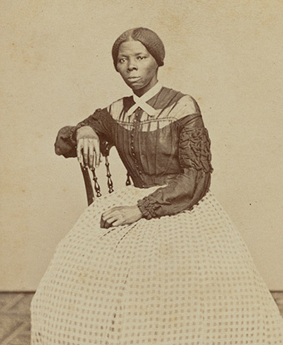
Harriet Tubman was born circa 1820 in Dorchester county, Maryland. She was one of nine children of a family of enslaved people. Her name at first was Araminta Ross. She later changed her first name to Harriet, which was her mother’s name.
In about 1844 Harriet married a free African American named John Tubman. In 1849, after hearing that she was going to be sold, she escaped to Philadelphia, Pennsylvania, without her husband.
In Pennsylvania Tubman became a “conductor” for the Underground Railroad. The railroad was a secret network that helped enslaved people find their way to freedom. By 1857 she had freed dozens of enslaved people, including her own parents. She said that she “never lost a passenger,” even though slave masters offered large rewards for her capture. It was an incredibly dangerous job to do. Even though many people (slave owners and the police) were out to catch her, Harriet Tubman remained a free woman.
After all the enslaved people were eventually freed, she settled in New York. Still very passionate, she worked for further equality between the races and also women’s rights. Her entire life was dedicated to helping other people. She was truly an inspirational person.
- Waar of niet waar?
- Harriet was eerst een slaaf, maar haar man niet.
- Harriet hielp in haar leven andere zwarte mensen ontsnappen uit de slavernij.
- Tijdens deze illegale missies was Harriet helaas ooit opgepakt.

- Open vragen. Antwoord in volledige zinnen.
- Wat was de ‘Underground Railroad’?
- Waarom was wat ze deed zo gevaarlijk?

Task 4 – Watching (The Klu Klux Klan)
After the enslaved people regained their freedom, the government (regering) tried very hard to ‘reconstruct’ the country. Black people had to become ‘normal’ members of society and therefore, many rules and situations had to be changed. This period is called the Reconstruction. Many white people were very angry that black people were equal to them now. Some white people even went as far as to create the Klu Klux Klan; a hateful, terrorist group that terrorized (and still terrorizes) black people in the US. They believe(d) in white supremacy. Learn more about the KKK by watching the video.
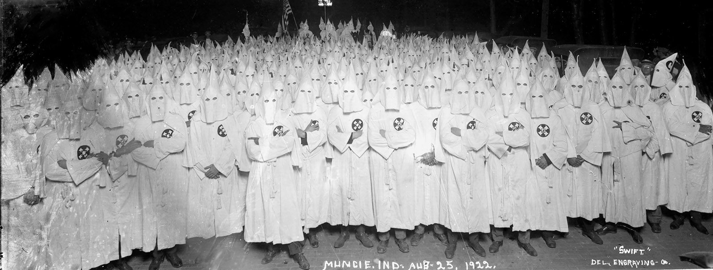
- First, look up the word ‘White supremacy’. Write down the meaning.
- Watch the video. If you find it difficult, you can watch the video in a slower speed.
https://www.youtube.com/watch?v=7o-uNsOMeV4
- Zou je de KKK omschrijven als vredelievend of gewelddadig? Leg je antwoord uit met voorbeelden uit de video.

Task 5 – Writing
In English, write down a short summary (80-120 words) of everything you’ve read and watched. What is, according to you, the most important information that someone should know?

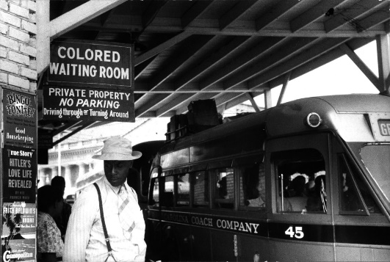
Part 2 - The US after slavery
Better times or more of the same?
Task 1 - Orienting
- What do you think happened after they abolished (afgeschaft) slavery? Did the situation get better, stay the same or get worse? Explain why.
Task 2 - Reading
Jim Crow laws
Jim Crow laws were an official effort to keep African Americans separate from white people in the southern United States for many years. The laws were in place from the late 1870s (after slavery was abolished ) until the civil rights movement began in the 1950s.
The name Jim Crow comes from a once popular stage performance that began in 1828. This type of show, called a minstrel show, involved entertainment that motivated a negative view of Black people. The term Jim Crow became a negative name for black people and a term for their segregation, which means separation based on skin colour, from whites.
Beginning in the late 1870s, Southern state lawmakers passed laws that forced white and black people to go to separate schools and to sit in different areas on public transport. The laws also included parks, cemeteries, theaters and restaurants. Blacks and whites had to use different drinking fountains, waiting rooms, housing and shops. Most black people were also unable to vote during elections. If they tried, they risked getting murdered for it. The laws kept black and white people from seeing each other as equals. The laws limited freedom and opportunity for African American people.
Each state had its own set of Jim Crow laws. Segregation spread beyond the South to other states in the country as well. Signs were used to show where “people of colour” were not allowed to go.
In 1954 the U.S. Supreme Court (Hoger gerechtshof) decided segregation in public schools was unconstitutional, which means that it was against the country’s set of rules. This decision was the beginning of the end for Jim Crow laws.

- True or false.

- Originally, the Jim Crow laws started in the North. T/F
- After 20 years, the laws were abolished (afgeschaft). T/F
- Each state had different Jim Crow laws T/F
- The laws were used to split up white people and black people T/F
- Open vragen. Antwoord in volledige zinnen.
- Waar komt de naam/term ‘Jim Crow’ vandaan? Antwoord in het Nederlands.
- Leg uit wat de Jim Crow wetten betekenden en wat voor invloed ze hadden op het dagelijks leven voor Afro-Amerikanen. Antwoord in het Nederlands.
- Langzaam maar zeker werden deze wetten afgeschaft. Wat was het begin van dit proces? Antwoord in het Nederlands.

Task 3 - Listening
During the Jim Crow period, the brutal lynching of black people is something that happened regularly, often the KKK was involved. Let’s discover what lynching is.
- Look up the word ‘lynching’, write down the meaning in English AND Dutch.
- Look up what the most common way to lynch someone was and write it down.
- Listen to the song below and read the song lyrics.
Billie Holiday was a well- known singer from the 1930s and 1940s. One of her best- known songs is “Strange Fruit”. https://www.youtube.com/watch?v=bckob0AyKCA
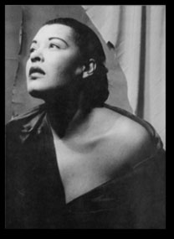
Strange Fruit- Billie Holiday
Southern trees bear strange fruit,
Blood on the leaves and blood at the root,
Black bodies swinging in the southern breeze,
Strange fruit hanging from the poplar trees.
Pastoral scene of the gallant south,
The bulging eyes and the twisted mouth,
Scent of magnolias, sweet and fresh,
Then the sudden smell of burning flesh.
Here is fruit for the crows to pluck,
For the rain to gather, for the wind to suck,
For the sun to rot, for the trees to drop,
Here is a strange and bitter crop.

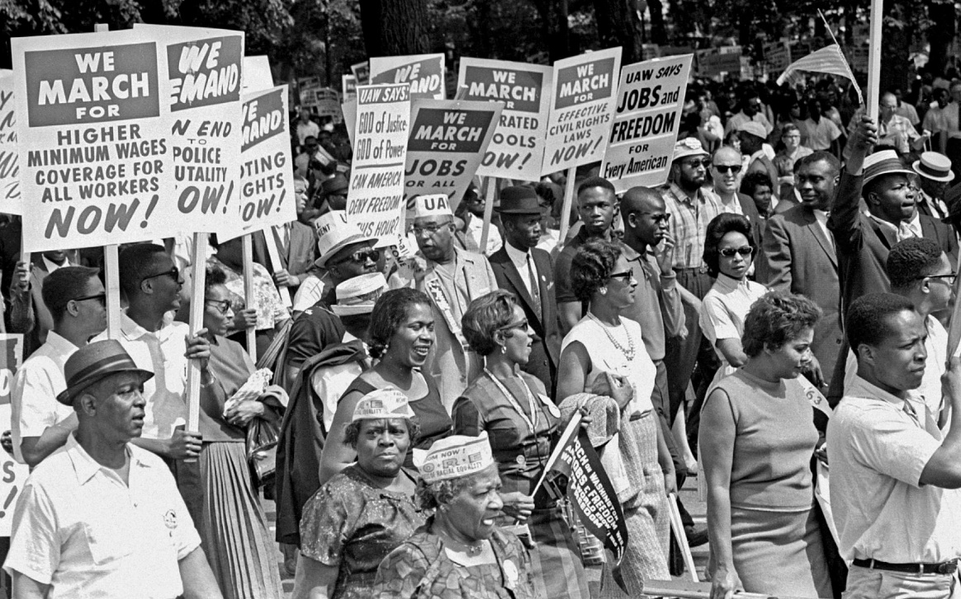
- Wat heeft ‘lynching’ met dit nummer te maken? Antwoord in het Nederlands.

Task 4 – Watching (Civil Rights Movement)
Black people became sick and tired of living in an incredibly racist society. They started to demand better living conditions and the change of people’s mindset, however, they weren’t the only ones. This period is called the Civil Rights Movement.
- Look up the meaning of ‘Civil rights’ and write it down.
- Look up the meaning of ‘boycott’ and write it down.
- Look up the meaning of ‘brutality’ and write it down.
- Watch the first 4 minutes of the video: https://www.youtube.com/watch?v=0UOTLqmRr2U
- Welke organisatie was belangrijk in de jaren 10 en 20 van de vorige eeuw?
- Wat veranderde in 1948 toen president Truman een nieuwe wet introduceerde?
- Wat gebeurde er toen rassenscheiding niet meer legaal was?

Task 5 – Research
Use Google and look up information about the following people. Write down a short description of about 40 words about these people. Who are they, what did they do for the movement?
Person 1: Dr. Martin Luther King Jr.
Description:
Person 2: Malcolm X
Description :
Person 3: Rosa Parks
Description:
Person 4: W.E.B. Du Bois
Description:

Task 6 – BLM
A lot of years have passed since then, but has it become better? Well yes, it has become a bit better, but unfortunately black people still face struggles just because they are black. Watch the video down below and answer the questions.
https://www.youtube.com/watch?v=YG8GjlLbbvs
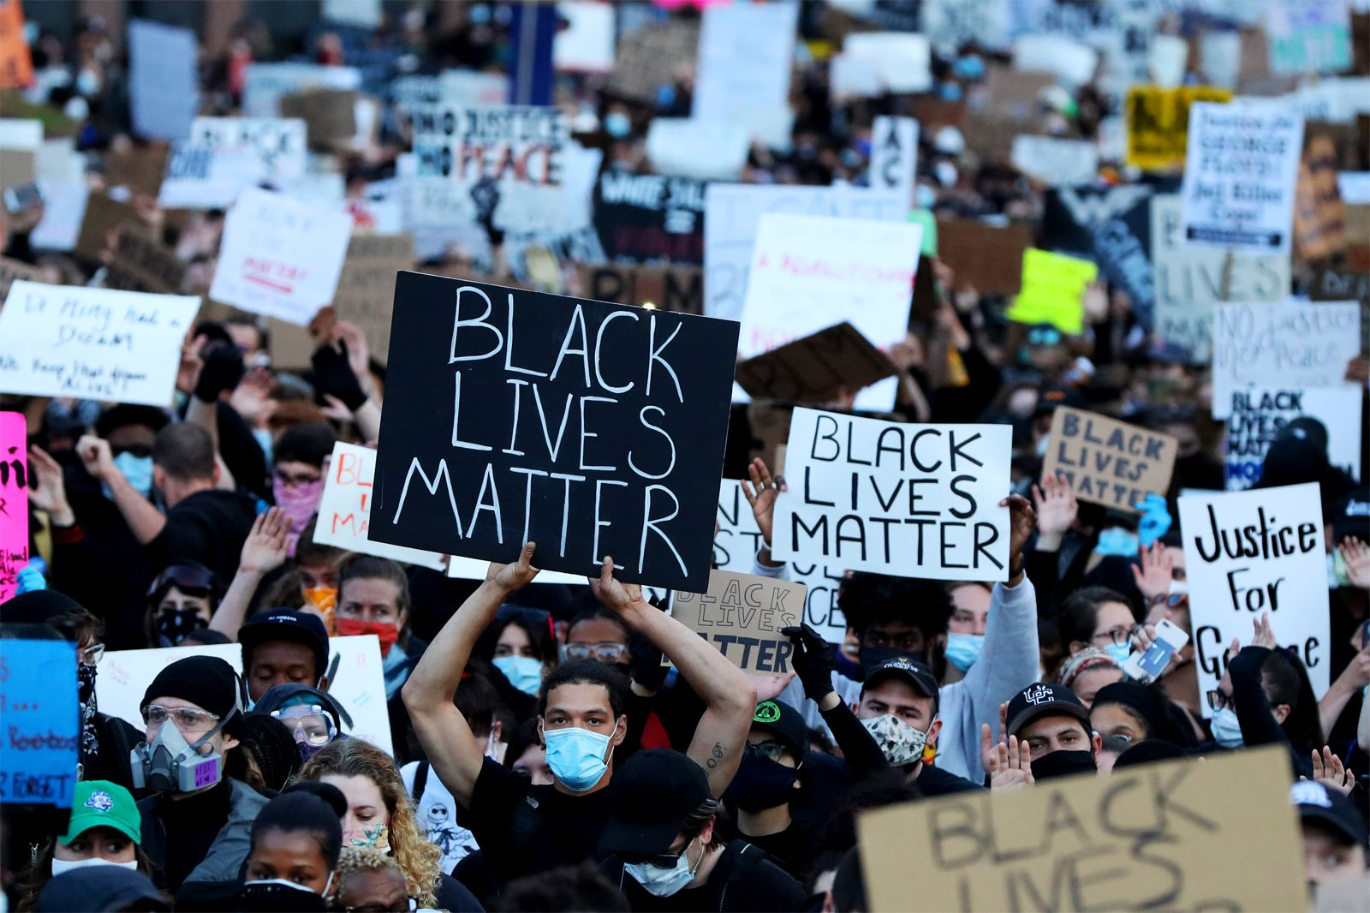

- Waar of niet waar?
- In Amerika worden er (ongeveer) even veel zwarte mensen en witte mensen vermoord door de politie.
- De BLM beweging steeg in populariteit in 2014 na de moord op Eric Garner en Michael Brown Jr.
- Doorgaans wordt politie niet meteen strafrechtelijk vervolgd nadat zij een zwart persoon om het leven brengen.
- Open vragen. Beantwoord in volledige zinnen.
- Wat had Obama gedaan om politiegeweld een beetje tegen te gaan?
- Wat veranderde nadat Trump president werd?
- Probeer uit te leggen waarom demonstranten in dit geval ‘Black Lives Matter’ gebruiken in plaats van, bijvoorbeeld, ‘All Lives Matter’.

Task 7 - Reflection

- How do you think we can stop racism? What can you do?
- What is the most important thing you have learned during this project so far? Explain why.
- Do you think problems will be resolved some day? Explain your answer.

Masterpiece – poster and presentation

Remember the 4 people we looked up? Dr. Martin Luther King Jr, Malcolm X, Rosa Parks and W.E.B. Du Bois? They were all important figures during the Civil Rights movement. We are going to do some more research on them.
Create groups of 3-4 people. The teacher will tell you which person your team gets.
Every group is going to create a poster, in English, with information about the person they got. When the posters are finished, every group will give a small presentation about their poster/person.
What you must include in the poster:
- A picture of the person
- The person’s name
- The year they were born and the year they died (e.g: 1899-1965)
- Sources (bronnenlijst) !!!
Research the following questions and include as well:
- How did this person experience racism during their life?
- Why were they important for the Civil Rights Movement and what did they accomplish?
- How did people describe their character?

Make sure your poster looks nice and attractive!

